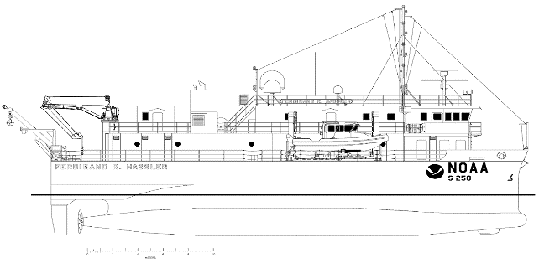**Standard Operating Procedure Document**

**Patch Testing**

**Revision History**

|  |  |  |  |
| --- | --- | --- | --- |
| DATE | DESCRIPTION | VERSION | AUTHOR |
| 2021 | Creation | 1.0 | LTJG Krabiel |
| 2023 | Expanded and edited | 1.1 | LT Debroisse |
| 2024 | Expanded, edited, for new Fish Haven Patch and Reference Surface area. | 1.2 | PS Stewart |
|  |  |  |  |
|  |  |  |  |

**Software Used**

* POSView (acquisition)
* Hypack (acquisition)
* SIS5 (acquisition)
* POSPac MMS (processing)
* Pydro Charlene (processing)
* Qimera (processing)

**Inputs**

* POS .000 files
* SIS5 .kmall files
* POS SBET
* Caris .svp

**Outputs**

* Updated SIS5 Installation Parameters (Angular Offsets)

1. S-250 Patch Test
   1. The principle of a calibration for a Dual Head Multibeam Echosounder is exactly the same as for a single head. Both heads should be calibrated separately, however. This document from Kongsberg:

**Kongsberg EM2040 Dual Head Calibration.pdf**, found here:

P:\Survey_Storage\04_SOPs\0_HSRR\3_Patch Test

provides a great overview and process for patch testing / calibrating dual head MBES systems.

* + 1. **Roll:** for each head three lines must be sailed over a flat area in opposite directions with the same speed.

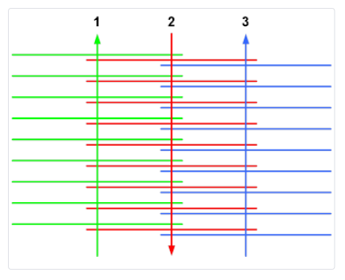

* + 1. **Pitch:** for each head two lines must be over an area with slopes (or an object) in opposite directions with same speed (individual transducer tracks on top of each other).

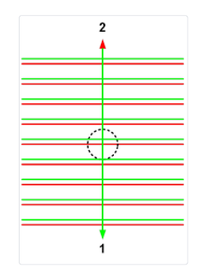

* + 1. **Heading:** for each head two lines must be sailed over an area with slopes (or an object), the lines need to overlap half a swath width, in the same direction with same speed.

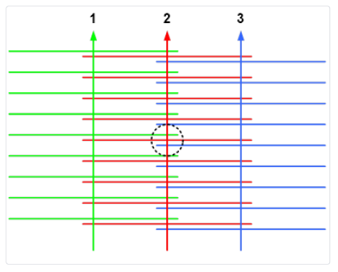

* + 1. **Timing:** no need to collect timing errors, thanks to the PPS in the POS
  1. 32nm ENE of Cape Henry, Fish Haven Wreck

**Collection**

* + 1. Returning the values in SIS to the 2019 SAT baseline values:
       1. Before the patch test lines are run, be sure to return the Roll, Pitch and Yaw values in SIS5 are returned to the correct values from the 2019 SAT. We cannot zero the values out because of the built in roll, so this is the recommended “zeroing” method for FH.
          1. View -> Installation parameters -> Transducer Setup

Delete the current offset and enter the final calibration values from the 2019 SAT for each value in the rows for PORT Transducer (TX-1 and RX-1) and for STBD Transducer (TX-2 and RX-2):

|  |  |  |
| --- | --- | --- |
| **Roll offset** | PORT TX-1 | 4.374 |
| PORT RX-1 | 4.374 |
| STBD TX-2 | -3.448 |
| STBD RX-2 | -3.448 |
| **Pitch Offset** | PORT TX-1 | 1.063 |
| PORT RX-1 | 1.063 |
| STBD TX-2 | 0.534 |
| STBD RX-2 | 0.534 |
| **Heading/Yaw offset** | PORT TX-1 | 0 |
| PORT RX-1 | 0 |
| STBD TX-2 | 0.899 |
| STBD RX-2 | 1.035 |

Press OK once the values are entered.

*NOTE: The SIS operators manual addresses dual head calibration rather than the Hassler’s unique setup, and states to add the values to the ‘Attitude’ rather than the TX/RX offsets. This SOP is using the method of “zeroing” to the SAT values from how Kongsberg initially conducted the harbor and field calibrations in 2019, which has worked so far. The system is different from a typical dual head setup, especially since there are 2 TPU’s, 2 Transmitters and 2 Receivers (essentially Hassler is 2 full systems plumbed together to produce a single swath and one .kmall file).

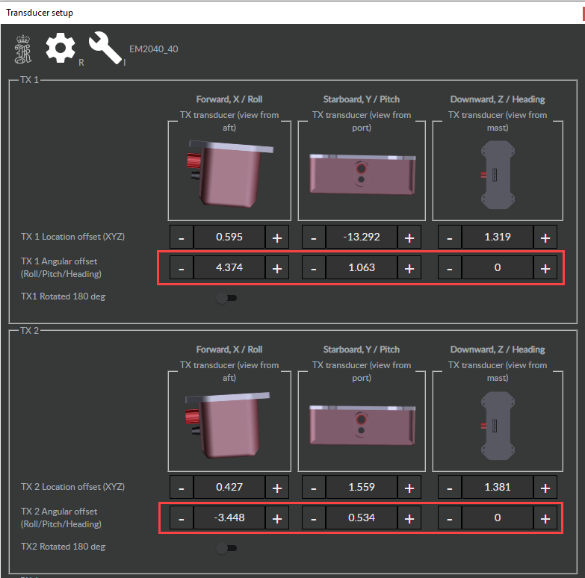

FH SIS5 PORT and STBD transmitter (TX-1 and TX-2) Offsets Page

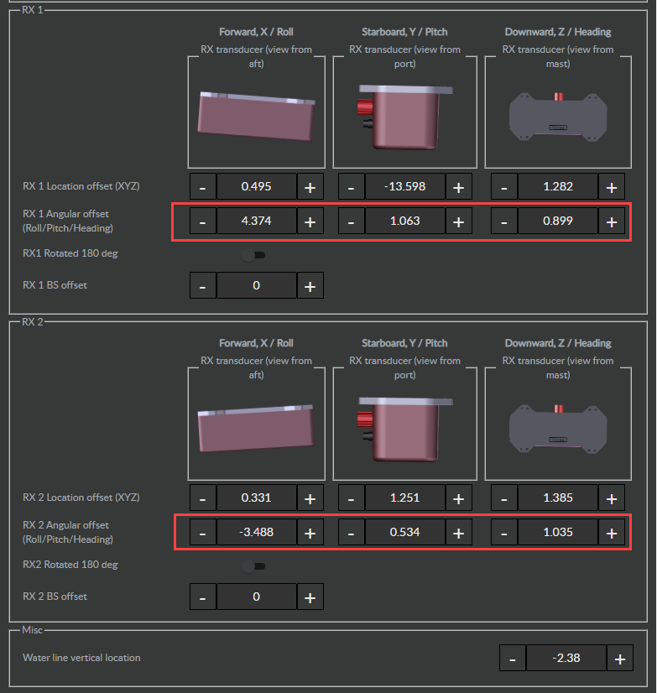

FH SIS5 PORT and STBD receivers (RX-1 and RX-2) Offsets Page

* + - * Deploy MVP prior to collection, or conduct a static cast
      * Have VDATUM SEP model or tide file ahead of time for smoother processing.

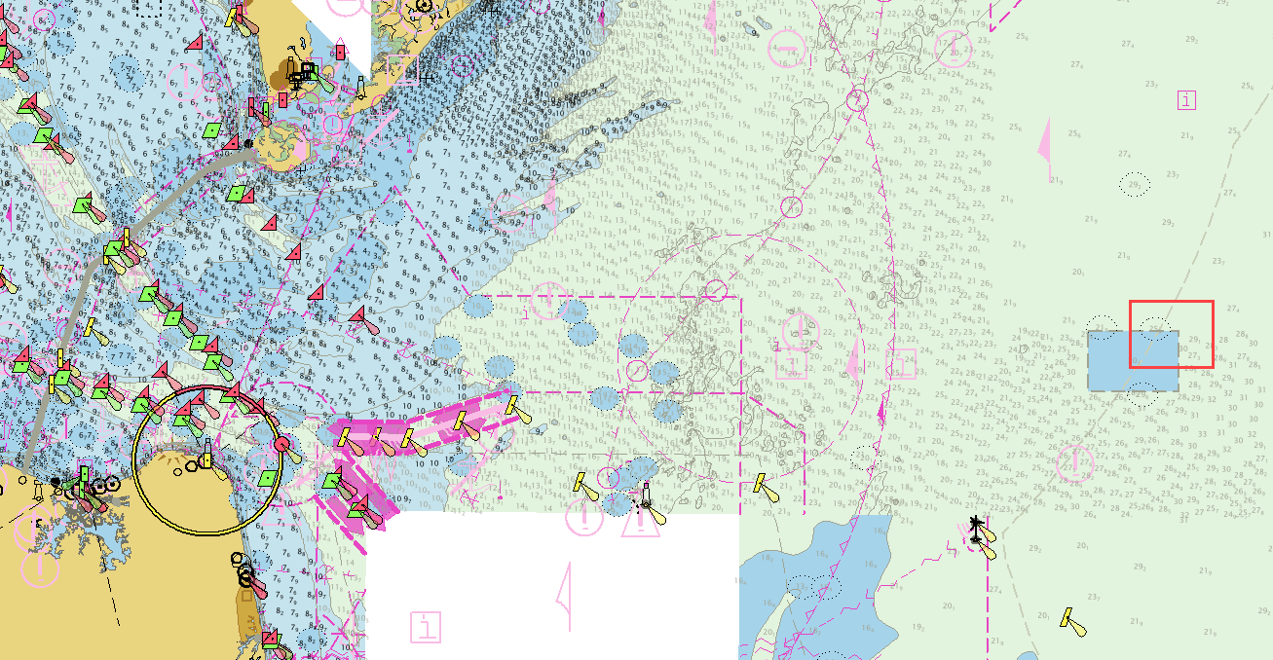

Figure 1: Patch Test Location

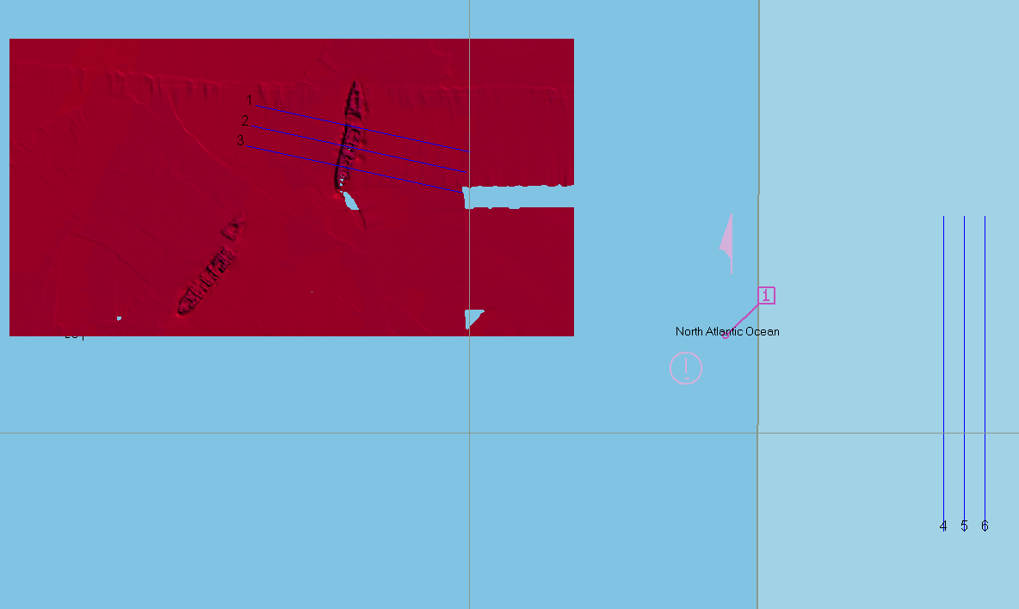

Figure 2: Patch Line Plan

Table 1: Patch test line setup and processing plan

|  |  |  |  |  |
| --- | --- | --- | --- | --- |
| **Line #** | **Calibration Test** | **Sonar** | **Speed** | **Direction** |
| 1 | Pitch / Heading (Yaw) | Port | 7-8 knots (survey speed) | West |
| 3 | Pitch | Port | 7-8 knots (survey speed) | East |
| 3 | Pitch | Stbd | 7-8 knots (survey speed) | West |
| 1 | Pitch / Heading (Yaw) | Stbd | 7-8 knots (survey speed) | East |
| 2 | Heading | Port | 7-8 knots (survey speed) | West |
| 2 | Heading | Stbd | 7-8 knots (survey speed) | East |
| 4 | Roll | Port | 7-8 knots (survey speed) | South |
| 5 | Roll | Port / Stbd | 7-8 knots (survey speed) | North |
| 6 | Roll | Stbd | 7-8 knots (survey speed) | South |

* + - 1. Notes:
         1. The offset between all survey lines in this plan is 24m which works well for the water depths in this area (~28-30 meters).
         2. Survey speed recommendation is only a recommendation, slower speeds will result in higher density of data.

**PROCESSING**

* + 1. Process an SBET using Charlene or POS Pac
    2. Process the CTD cast into CARIS SVP format using Sound Speed Manager
    3. Processing in Qimera:
       1. Open Qimera
          1. A “Create Project” window will open.

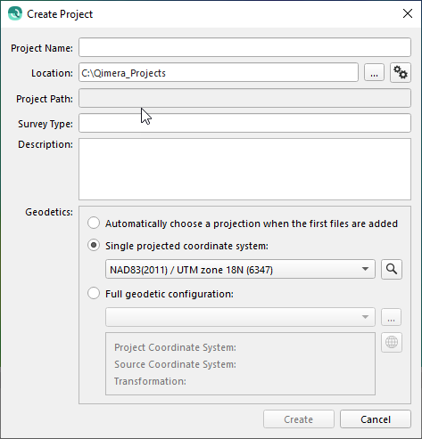

Give your project a name, select a project folder location or use the default. Under “Geodetics” select “Single projected coordinate system:” and either use the pull down to scroll and find “NAD83(2011) / UTM zone XXN” or use the search magnifying glass to search and find your selected projection:

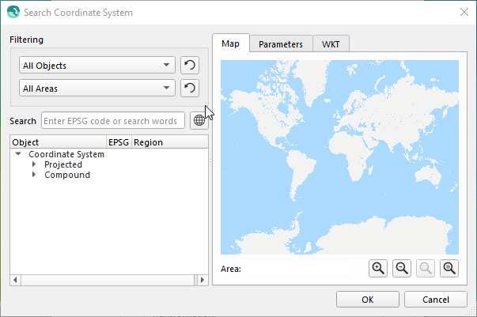

* Convert VDatum Separation model from CSAR to BAG and ensure the BAG opens in your project.
  + Layer → Import Grid. BAG will convert to SD object automatically

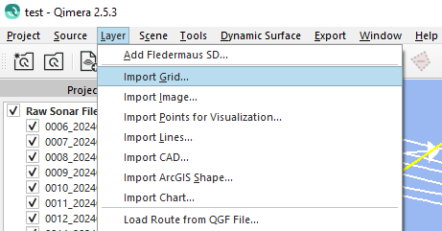

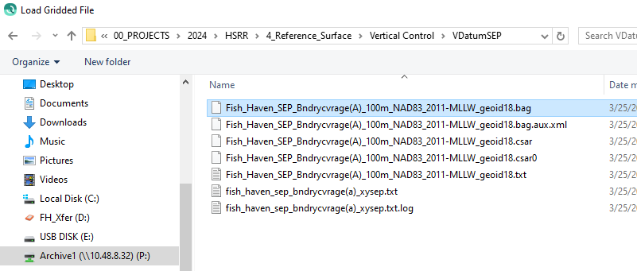

* A few window prompts will come up:

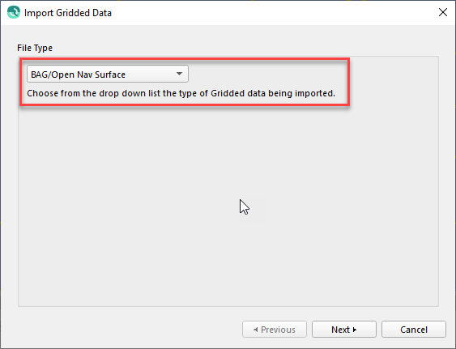

* Hit Next and select your appropriate Coordinate Reference System:

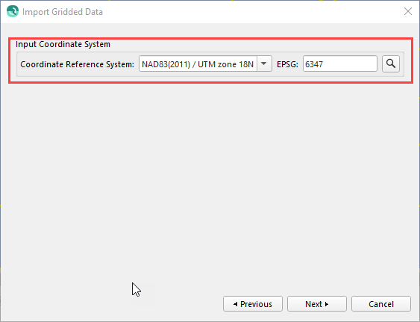

* The defaults / greyed out info in this window is fine:

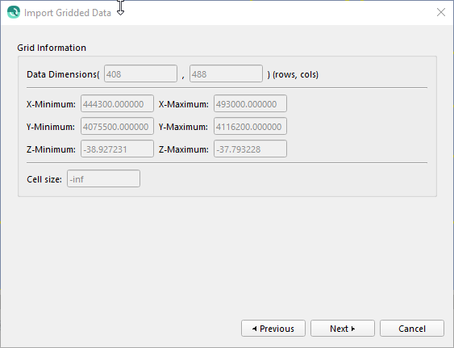

* Hit next and you will see this:

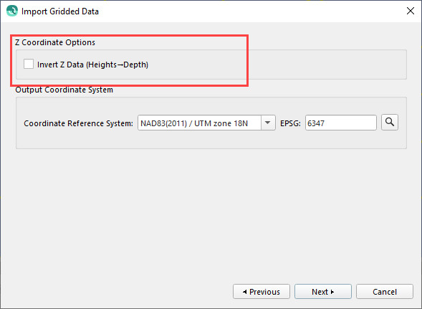

* **The window above is important.** Depths in Qimera are negative DOWN unlike Caris which is positive DOWN. Leave the Invert Z Data (Heights->Depth) UNCHECKED, or your grid surface will have some really strange depths not referenced to MLLW>
* Hit Next:

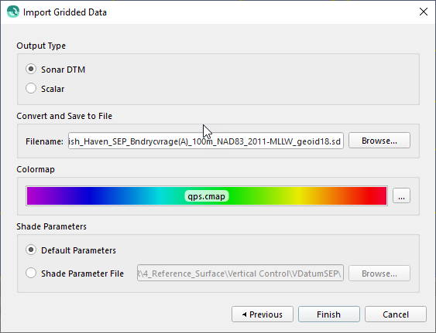

* Click Finish.
* The SD object created will be the separation model you later apply in Qimera.
  + - 1. Load your raw sonar files
         1. Source -> Add Raw Sonar Files (you can either Add individual files or add a whole directory:

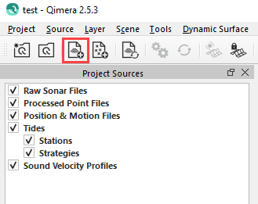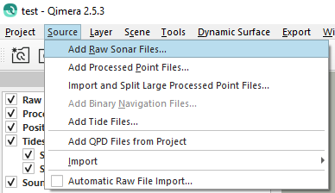

* + - * 1. Under “Vessel Assignment” be sure it is “Auto detect vessel configuration…”, and under “Coordinate System of the Imported Data”, it should be the coordinate system of the .kmall files which should be WGS84 (the Qimera Project will be in NAD83(2011) as chosen in step a. above.

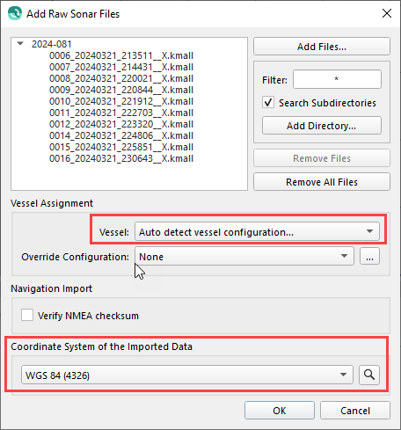

* + - 1. The added raw sonar files (.kmall) to be used with the patch test tool will appear in the Project Sources window:

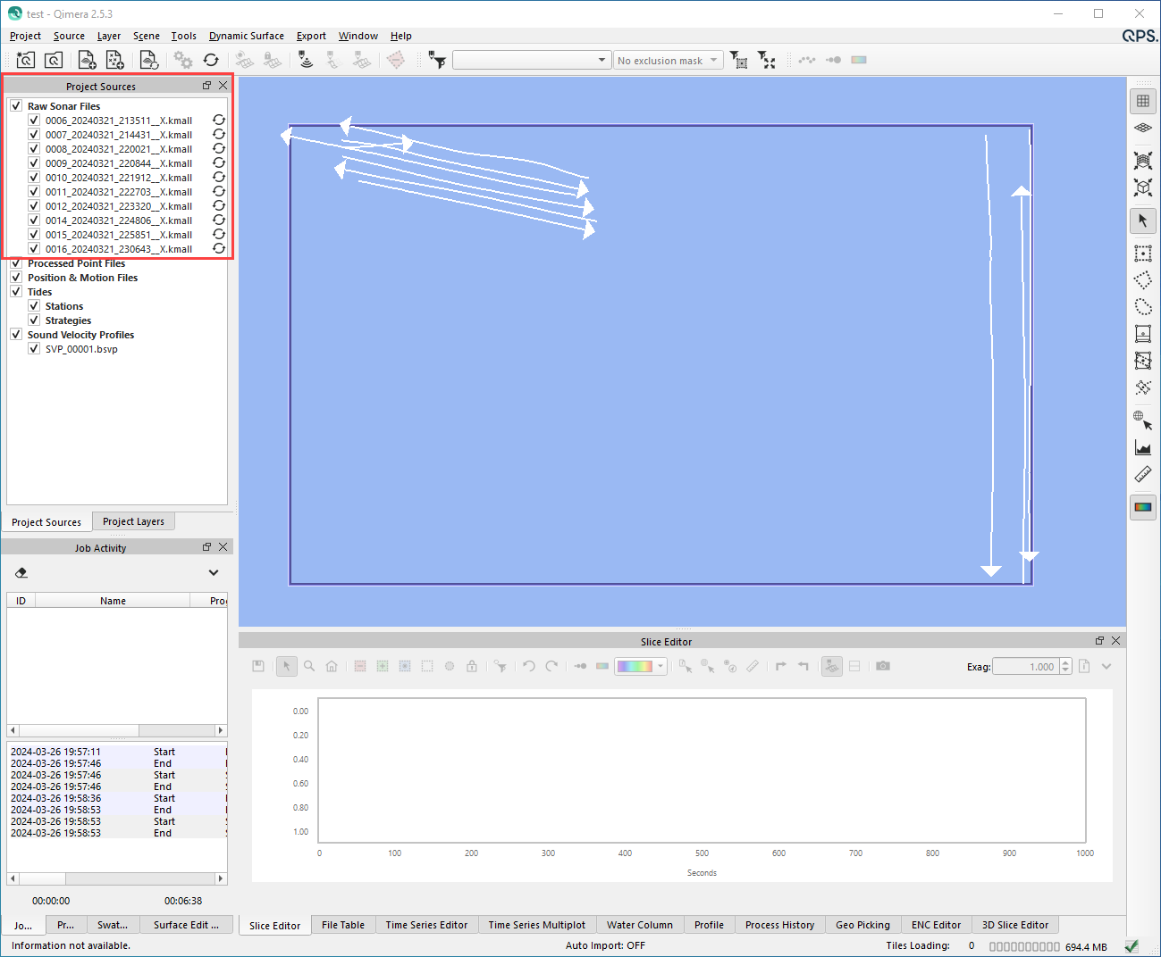

* + - * 1. You will see a double arrow just to the right of the loaded files. This indicates the raw files need to be processed. You can either hit the “Auto Process” button now in the toolbar above, or you can wait and load the SVP(s), POS delayed heave (.000), and SBET (.out), files first and then process it all at once. If you do it in steps (which is fine) the program will prompt you to process each time you load new Source files)
        2. Note: Qimera builds a Vessel Config file based on the .kmall data in the first line you import. The values in this file will be the ones the patch test starts on.
      1. Import the sound speed, Source -> Import -> Caris SVP

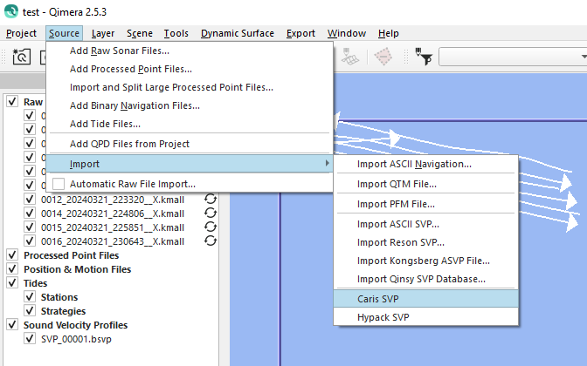

It will then prompt you to select your vessel configuration which will be what Qimera generated from the raw .kmall file import  
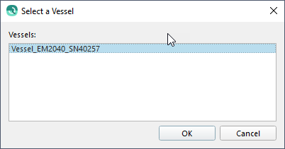

* + - 1. Import the POS .000 (files for delayed heave), Import -> Add Binary Navigation Files…

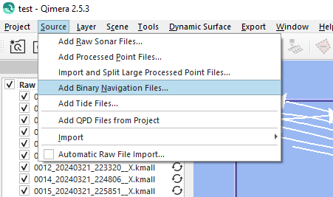

Select the file(s) you want to import:

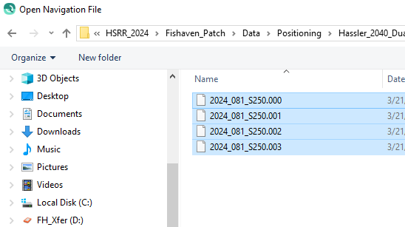

You will see a popup warning / statement (if you load multiple files):

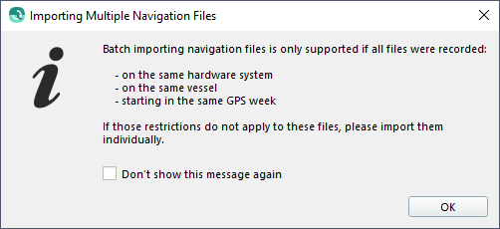

* Hit OK. Now you will see another window pop up “Import Navigation”. In this window we will create a new Motion Reference System for the POS True Heave data:
* Hit the button under “Motion Reference System”, see below. Ensure correct vessel assignment
* Create new Motion System Reference
  + - * + Give it a name, e.g., “FH_DH”
        + Offsets can remain 0,0,0 because delayed heave is measured at the RP (IMU)
* Check box to extract “True Heave”
* “Use as primary source” will be selected by default
* Ensure correct GPS week
* Specify coordinate reference system

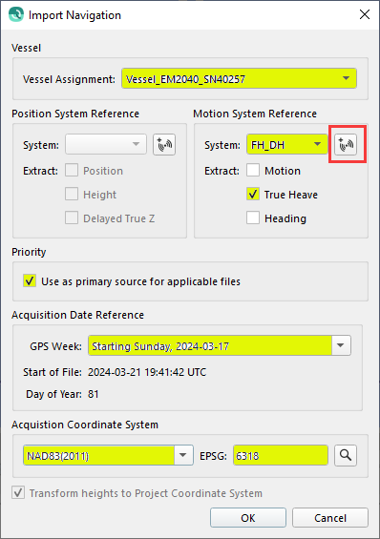 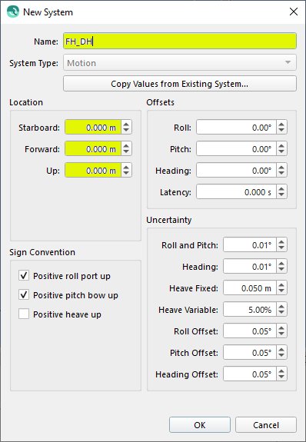

* Once you hit OK, you will see the .000 files loading in the Project Sources window under Position & Motion Files
  + - 1. Import the SBET .out file(s), Import -> Add Binary Navigation Files…



Select the file(s) you want to import:

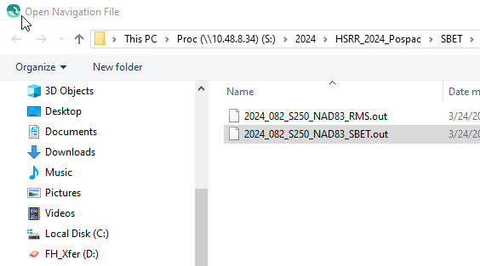

**NOTE:** For importing the SBET file(s), only select the SBET .out file, no need to select the RMS .out file(s).

* Hit OK. Now you will see another window pop up “Import Navigation”. In this window we will create a new Motion Reference System for the POS True Heave data:
* Hit the button under “Position System Reference”, see below.
* Ensure correct vessel assignment
  + - * + Create new Position System Reference
        + Give it a name, e.g., “FH_SBET”
        + Offsets can remain 0,0,0 because delayed heave is measured at the RP (IMU)
* Check box to extract “Position and Height”
  + - * + This will reference the data to the ellipsoid
* “Use as primary source” will be selected by default
* Ensure correct GPS week
* Specify coordinate reference system

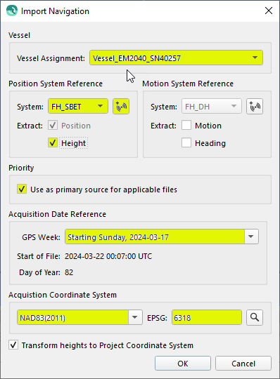 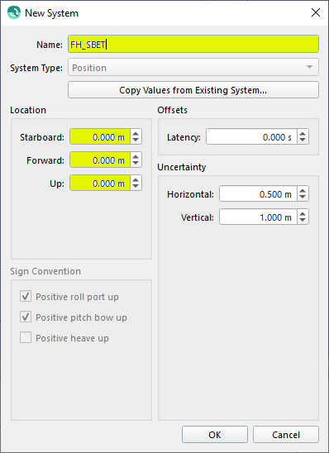

* Once you hit OK, you will see the .out file loading in the Project Sources window under Position & Motion Files
  + - 1. Check / Edit the processing parameters:
         1. Select all the lines you want to process

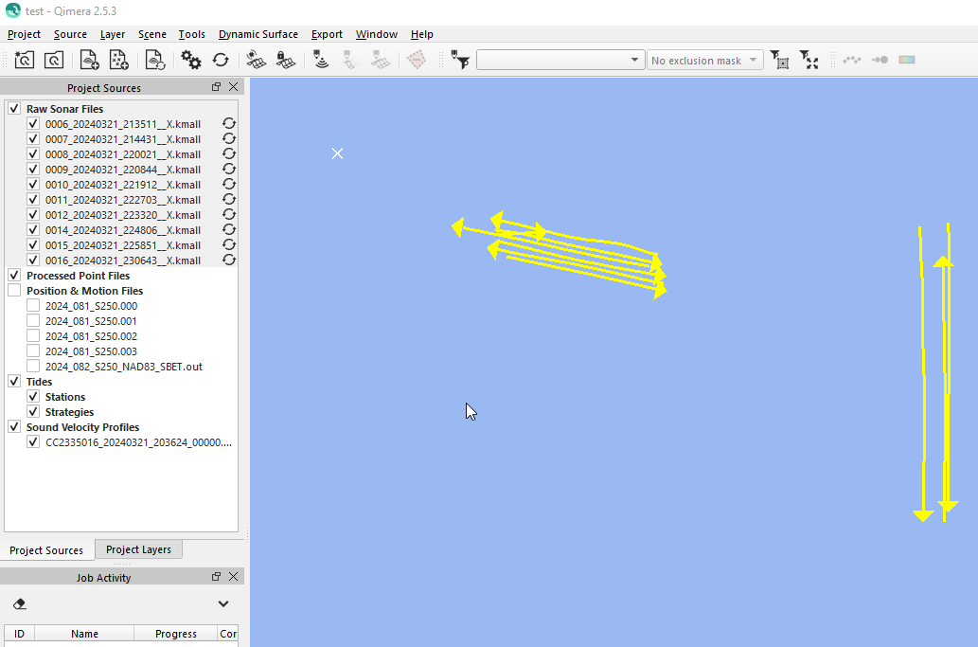

* + - * 1. Either Right-Click -> Edit Processing Settings or hit the Edit Processing Settings button on the toolbar:

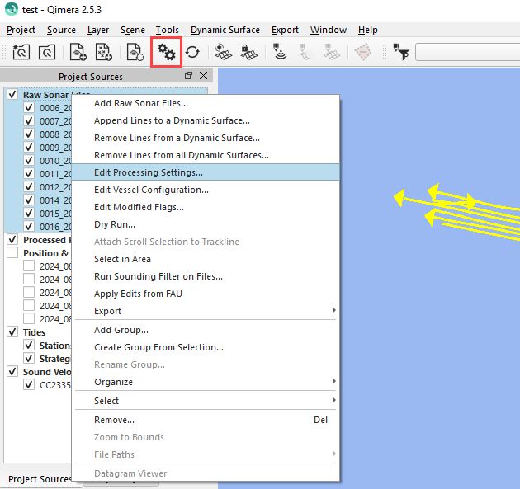

* + - * 1. Sound Velocity Tab:

Choose strategy, e.g., Nearest in distance within time of 240 minutes (4 hours).

Use Surface Sound Speed as first entry in raytrace profile.

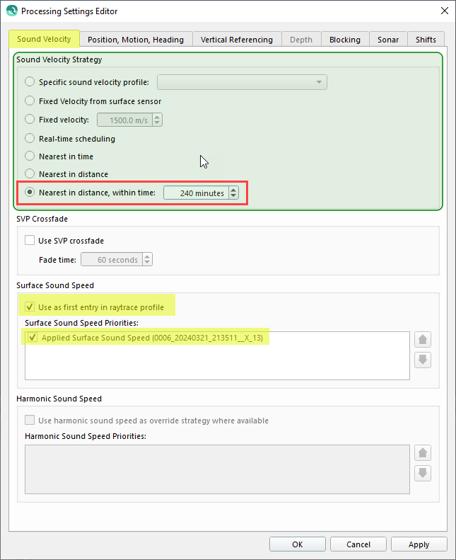

* + - * 1. Position, Motion, Heading tab.

Ensure “FH_SBET” is on top in the Position Source Priorities window.

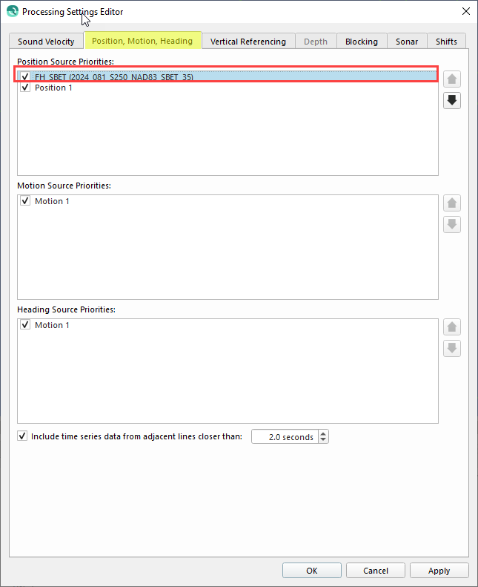

* + - * 1. Vertical Referencing Tab.

Ensure GNSS/GPS selected with “FH_SBET” on top

This is also where you can load the SEP model created earlier. Load the SD object that was converted when imported from the BAG file. In addition, enter the SEP model uncertainty just to the right of the filename where it says “SD model:

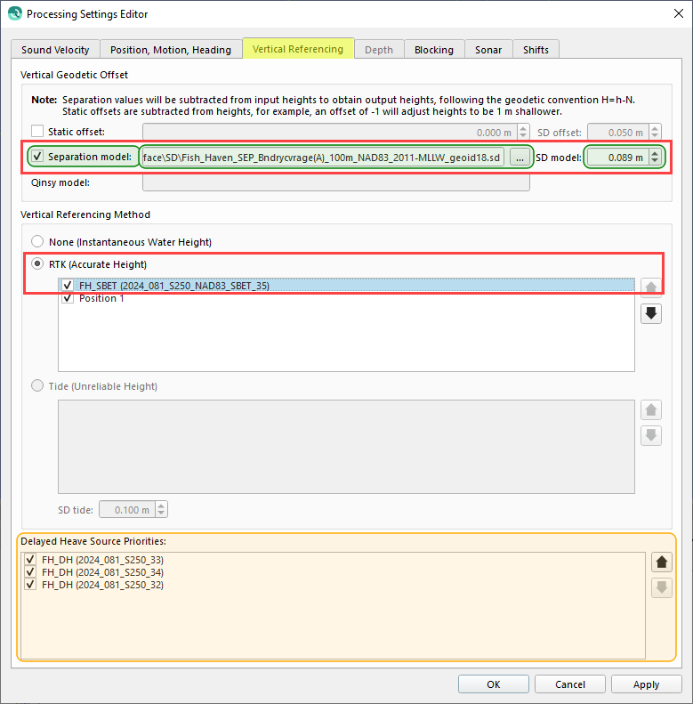

* + - 1. Auto process the lines.
         1. You may see a blue banner at the top of the map display window asking if you want to “reprocess the affected files now?”, click yes, or, alternatively, you can select all of your loaded raw data files by clicking the bolded “Raw Sonar Files” under the “Project Sources” window, and then hit the Auto Process button to fully process all the files:

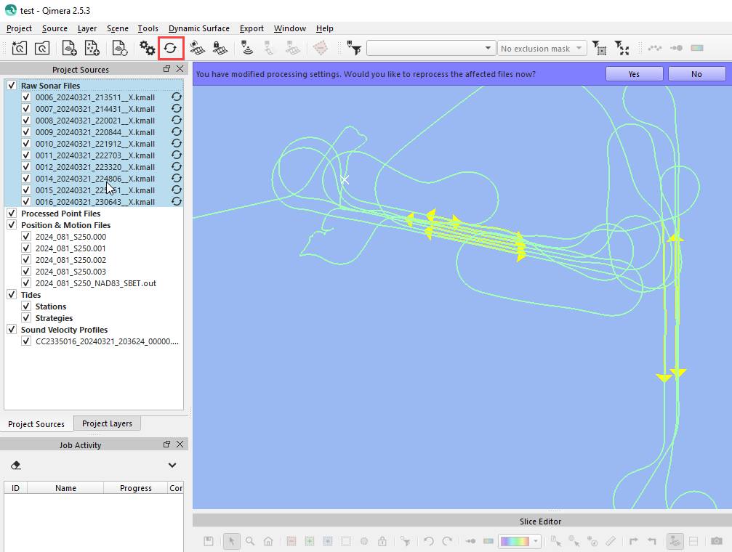

* + - * 1. Next you will see a blue banner at the top of the map window saying you now have processed files and asking if you want to create a new dynamic surface:

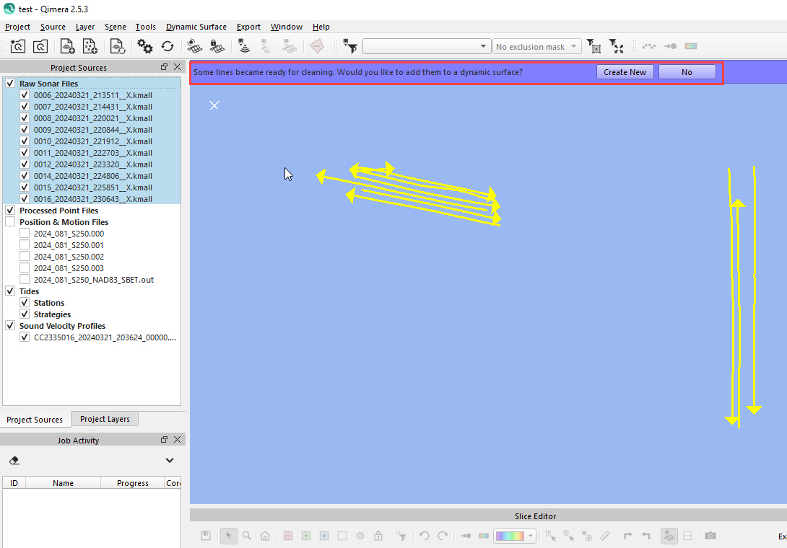

* + - * 1. Click create new. A window will pop up asking a name for the new Dynamic Surface and some settings for Cube and Cube settings:

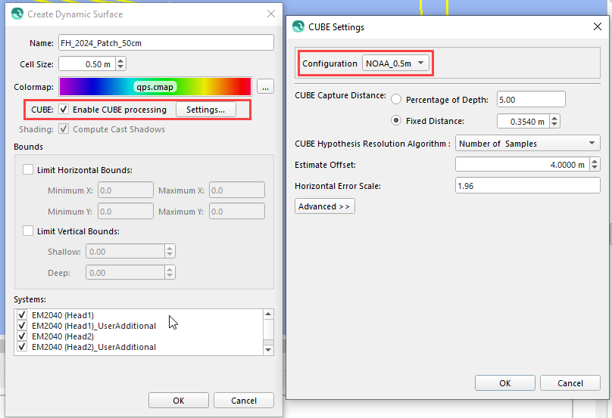

Once you hit OK on those windows your new Dynamic Surface will appear in the map window.

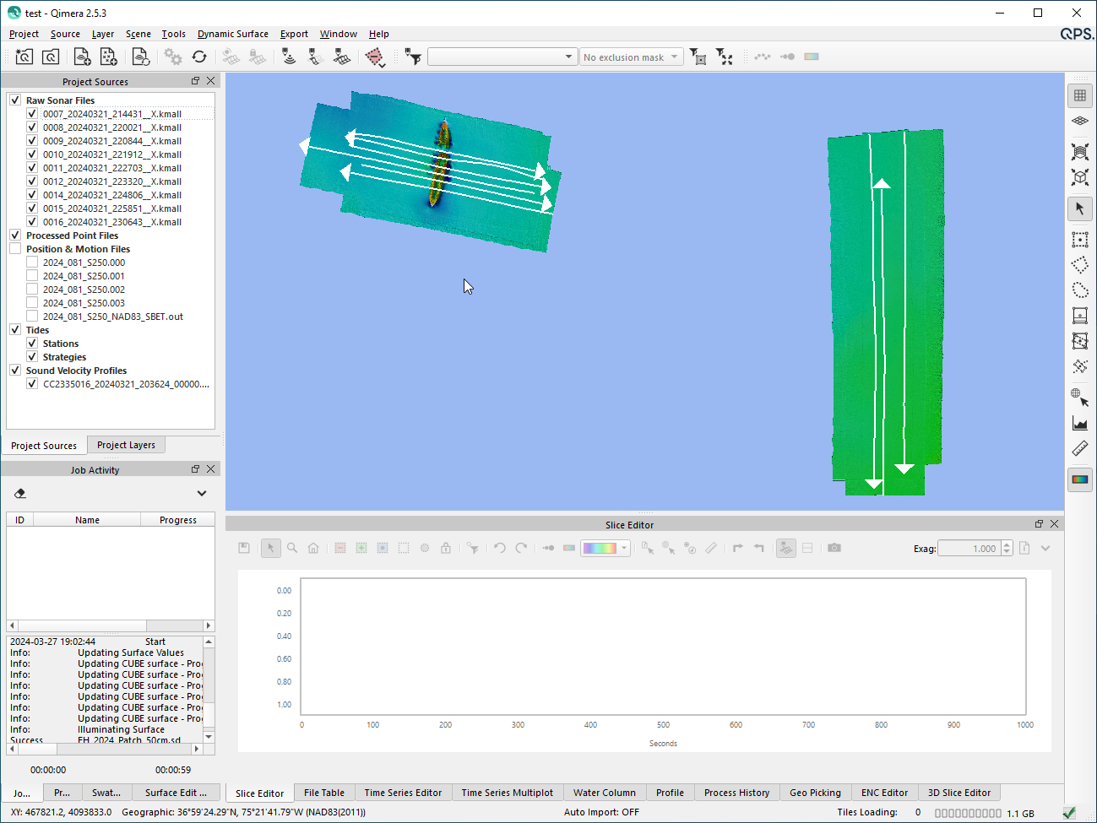

**Finally, getting to the Patch Test…**

* + - 1. Select all of the lines (under Raw Sonar Files) you wish to patch test with. Choose relevant lines for roll, pitch, heading.

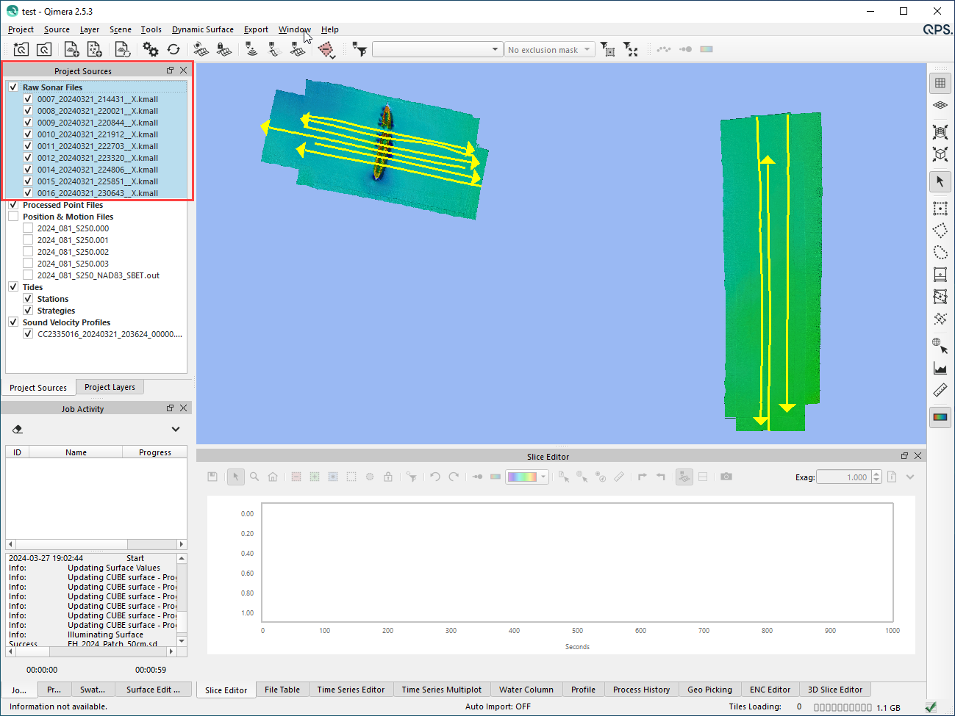

* + - 1. Go to the “Tools” menu and select “Patch Test Tool”
         1. For dual head, make sure the two little sonar heads in the right side of the toolbar are selected to make sure both head’s worth of data is in the window. Then, turn off whichever head you aren’t calibrating. Head 1 is PORT, Head 2 is STBD:

The “current calibration” window should change to look like this. Turning off a head in the Patch Test Plot window as described above will gray out the unselected head under the Current Calibration area:

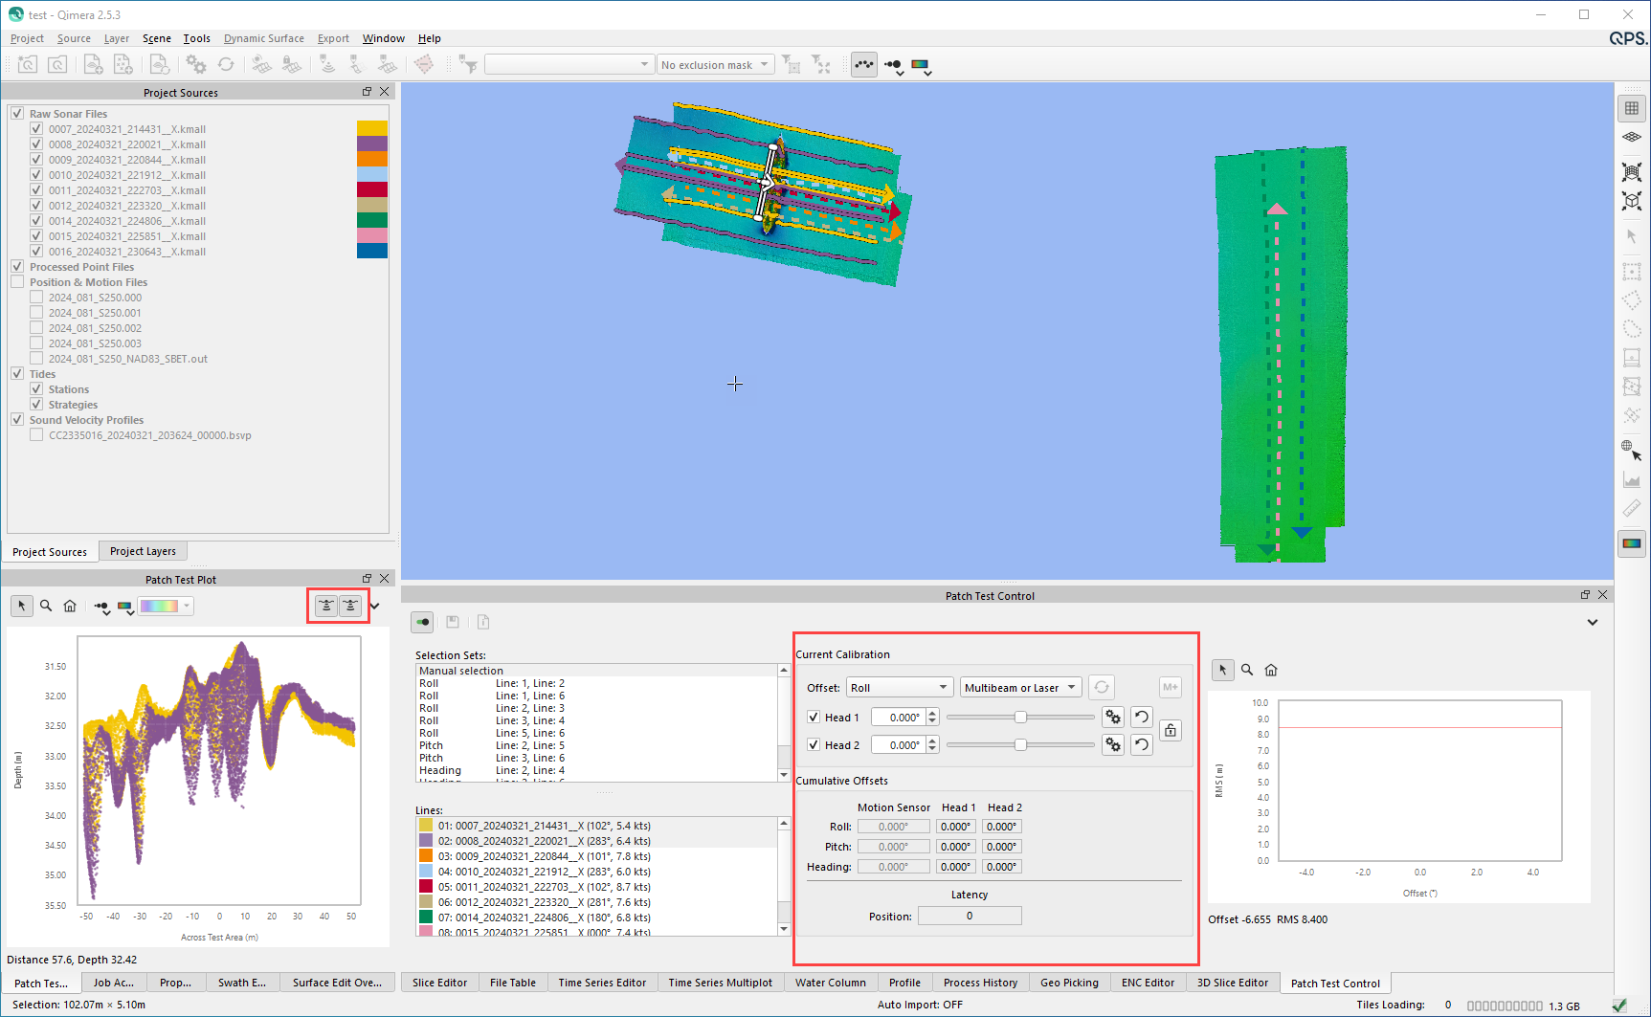

Both heads should be adjusted independently by turning on and off the data as shown in step i. Do not use the check boxes or the lock function.

* + - * 1. Process lines in the following order:

**Roll** (do once for Head 1 (Port) and again for Head 2 (STBD). For Head1/Port select the two lines as per the HSRR plan for Port Roll (will be two lines, opposite direction with the Port sonar overlapping:

Select two lines in the “Lines” window. The selected lines will have a blue highlight and all other unselected lines will not. The “Selection Sets” window is just above the “Lines” window. This is Qimera trying to automatically figure out which lines should be for which calibrations, but for dual heads this does not work well and can be ignored. Use the information from Table 1 above that shows the line plan and which lines are for which calibrations for which sonar (Port/Head1, Stbd/Head2).

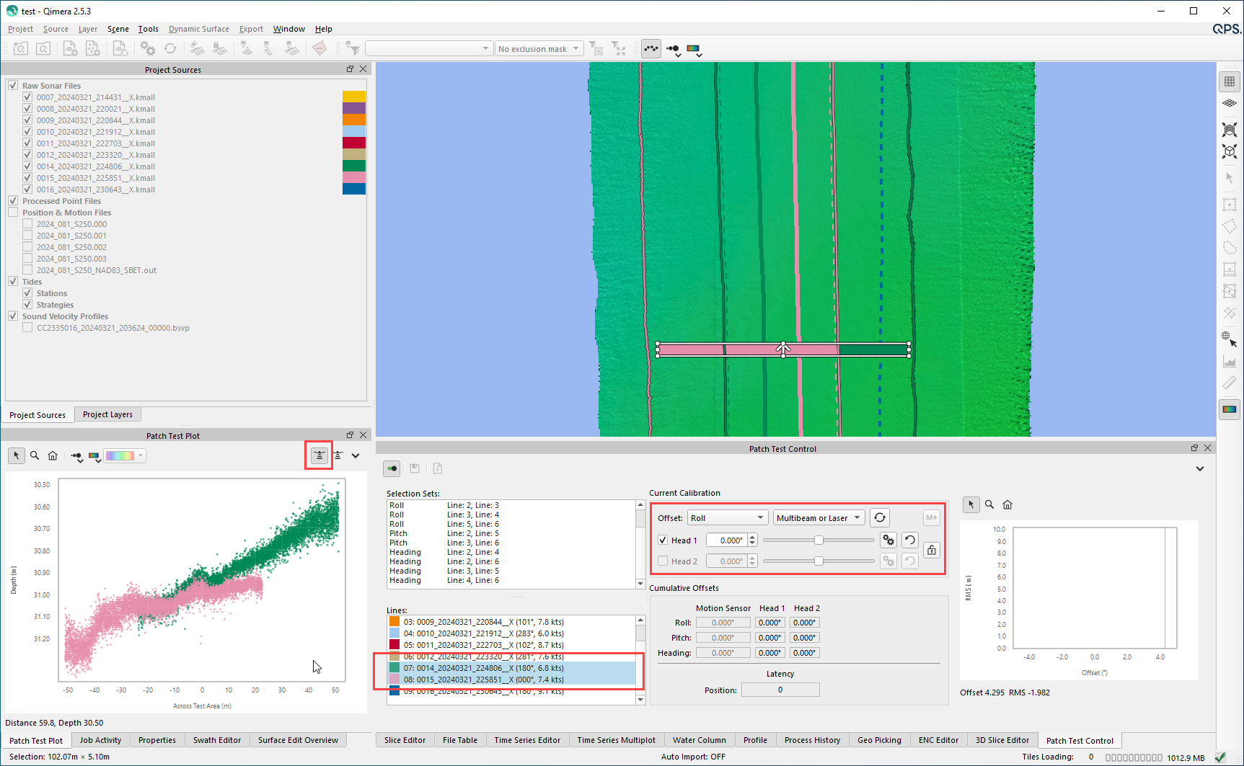

Example above is for Roll, Port (Head1). Notice that only the left sonar (Port/Head1) is selected in the Patch Test Plot window 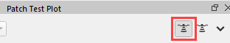, and only Head 1 is checked under the Patch Test Control window, Current Calibration sub-window 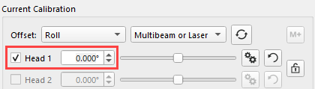. Also Note, that in order to check / uncheck the different Heads in the Current Calibration area, you must have the correct Head selected in the Patch Test Plot window.

Adjust the location of the selection box within the lines- should be oriented 90 degrees to the lines

Ensure “roll” is selected in the Offset pull-down menu

Click the “Auto Solve” button (opposing circular arrows), or manually type in values/ move the slider.

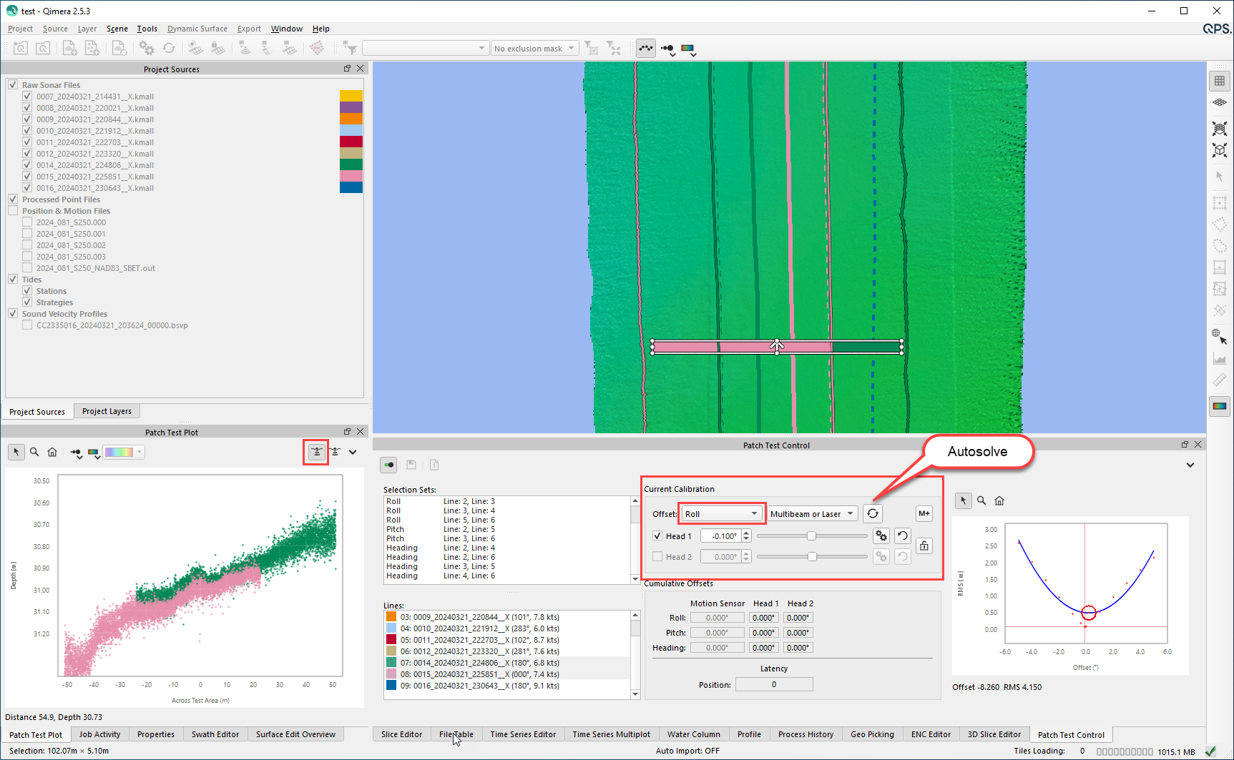

Record the value of the “offset” that you determined is the best result in a spreadsheet and as well once you are satisfied you can hit the **M+** button and it will save the value that will be used later to generate a patch test report.

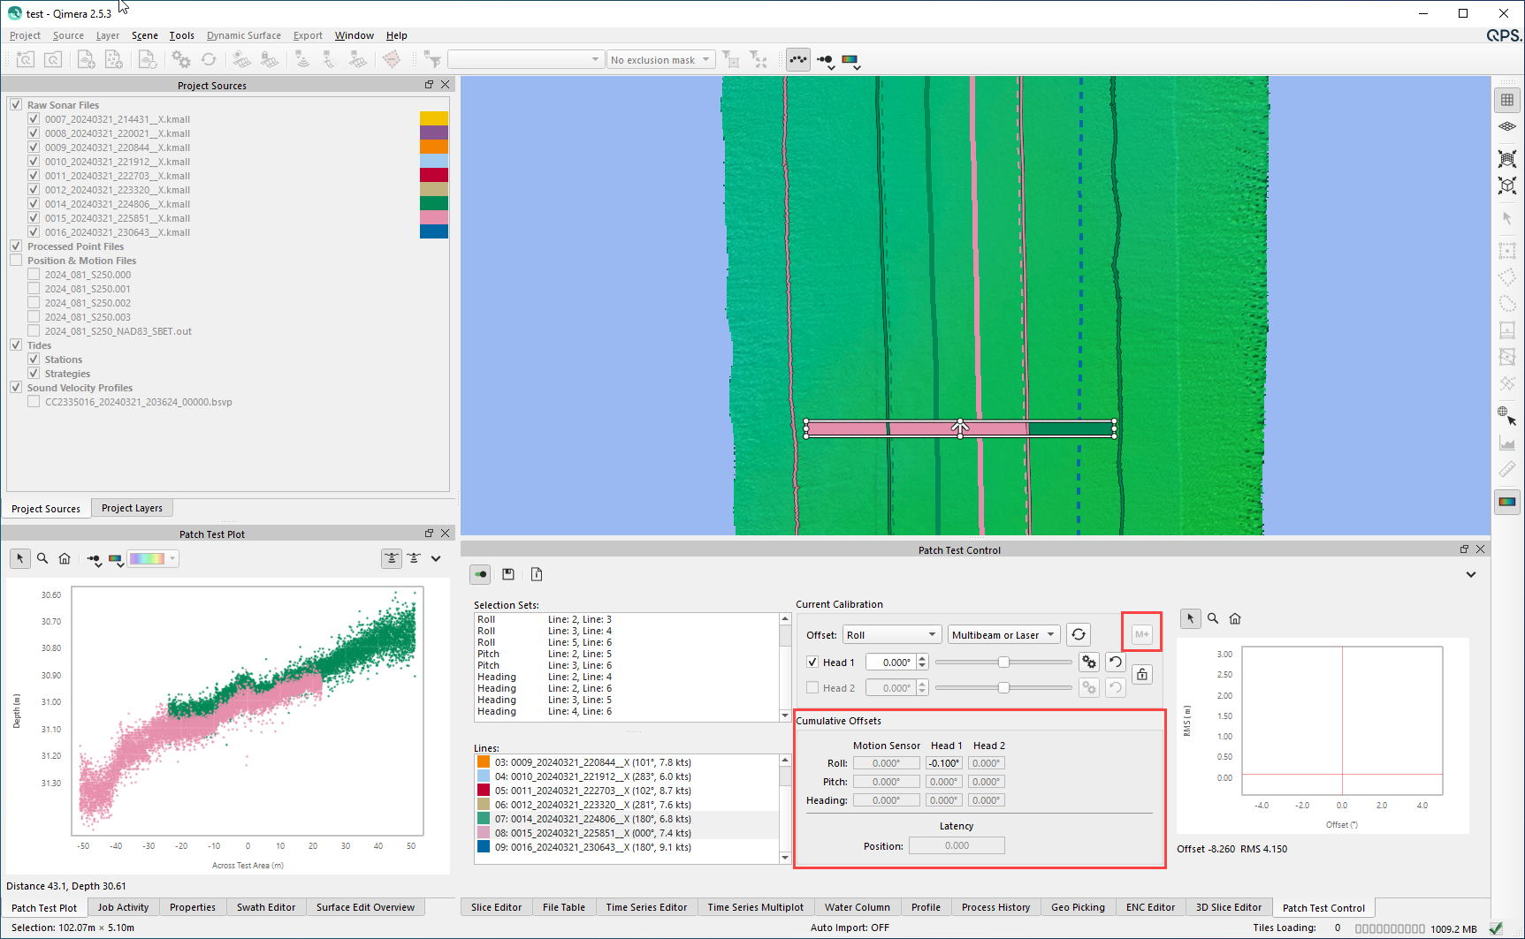

Pitch

Repeat the same steps as above (once for each Sonar (Port/Head1, Stbd/Head2), but selecting “pitch” in the Offset pull-down menu after selecting two lines appropriate for Pitch (opposing lines, opposite directions, over a significant object or slope, with the same sonar overlapping (e.g., Port/Head1 to Port/ Head1, Stbd/Head2 to Stbd/Head2)

The selection window should be oriented parallel to track

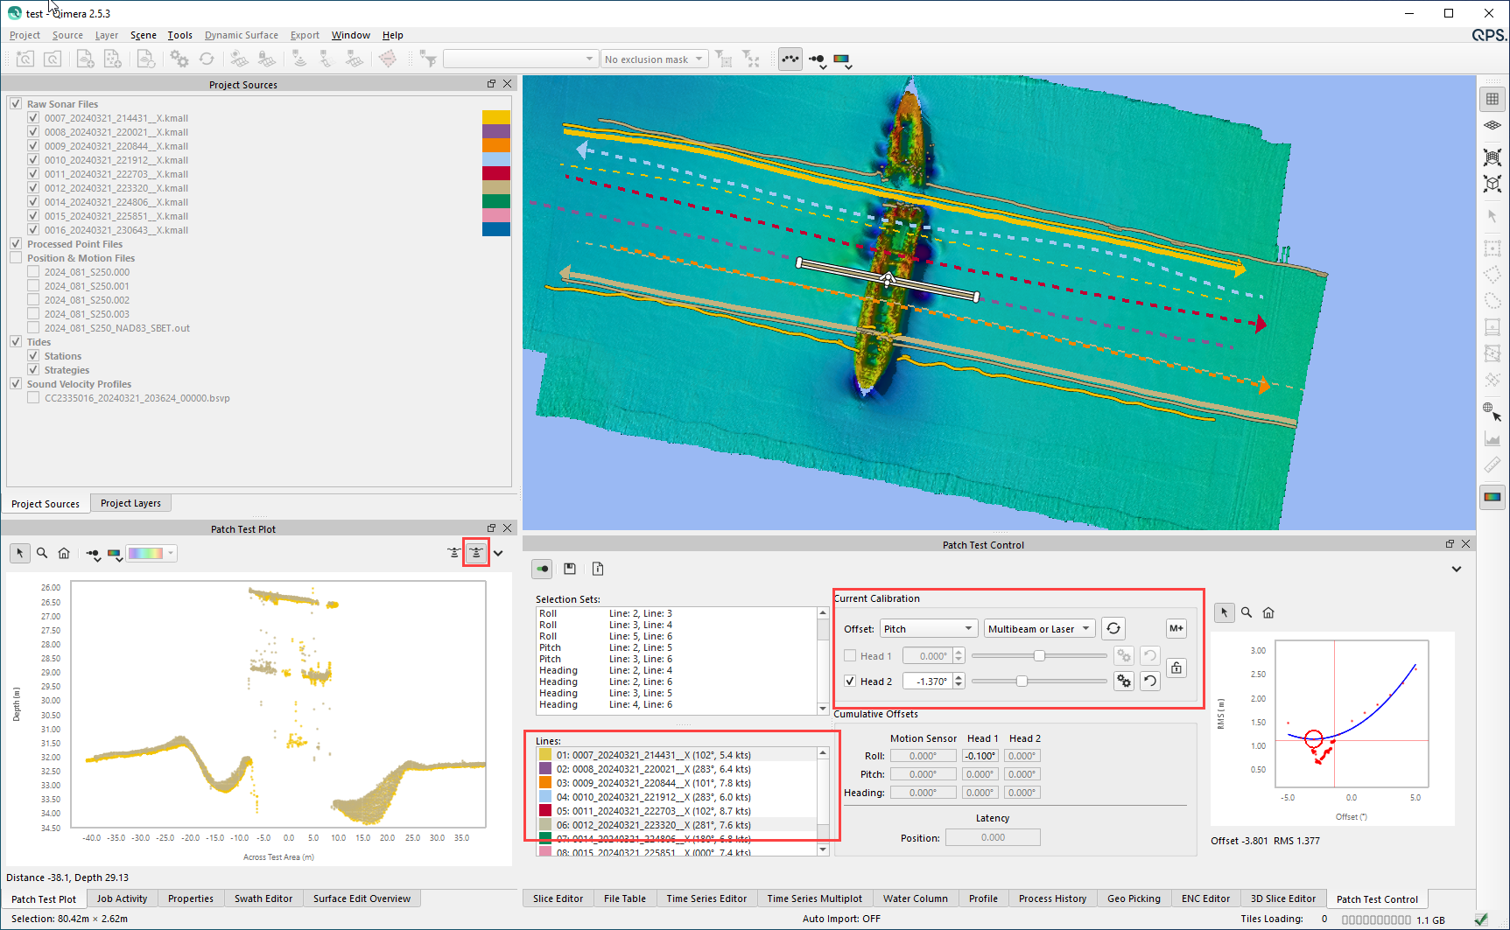

Example above is for Pitch, Stbd / Head2

Heading

Repeat the same steps as above (once for each Sonar (Port/Head1, Stbd/Head2), but selecting “Heading” in the Offset pull-down menu after selecting two lines appropriate for Pitch (opposing lines, same direction, over a significant object or slope, with the same sonar overlapping (e.g., Port/Head1 to Port/ Head1, Stbd/Head2 to Stbd/Head2)

The selection window should be oriented parallel to track

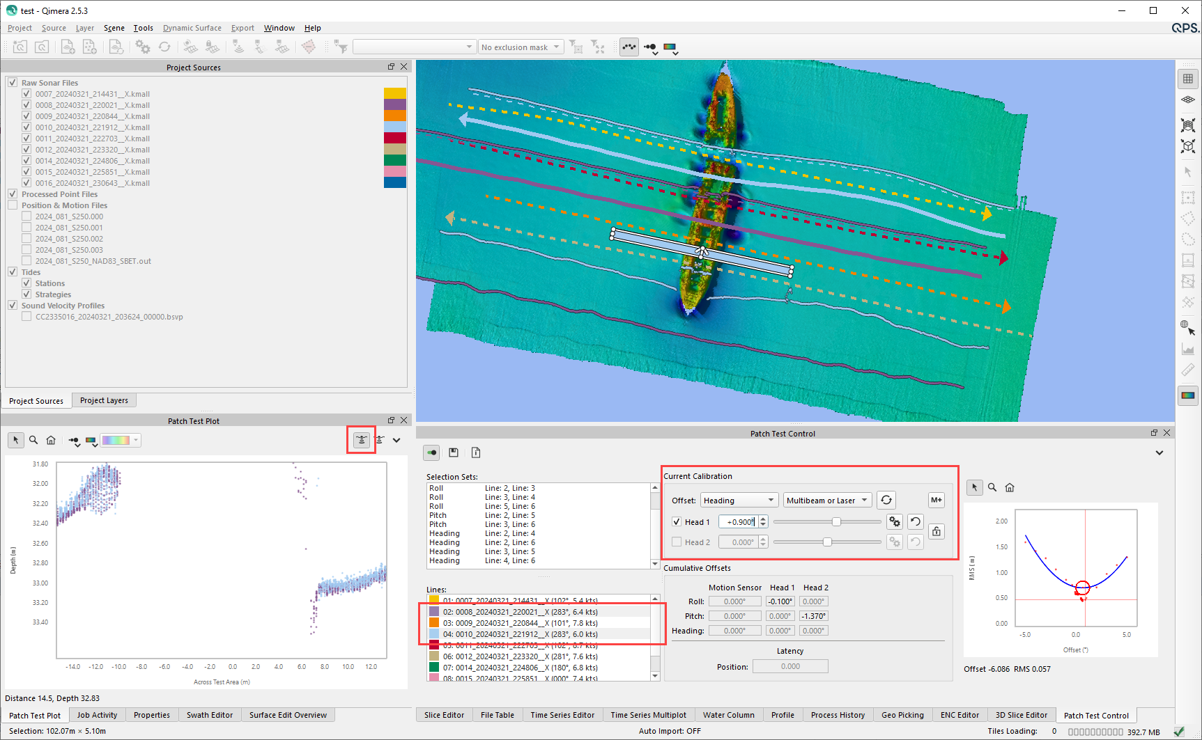

Example above is for Heading, Port/Head1

Once one person is done getting values close the patch test tool and when prompted if you want to save the values select NO so that the next person to run the calibration starts with the same starting values.

Once the values have been determined for all three tests and for both sonars, and the values are shown in the “Cumulative Offsets” sub-window in the Patch Test Control area, the Save button (disk icon) can be clicked in order to save a detailed report of the patch test calibration results to PDF:

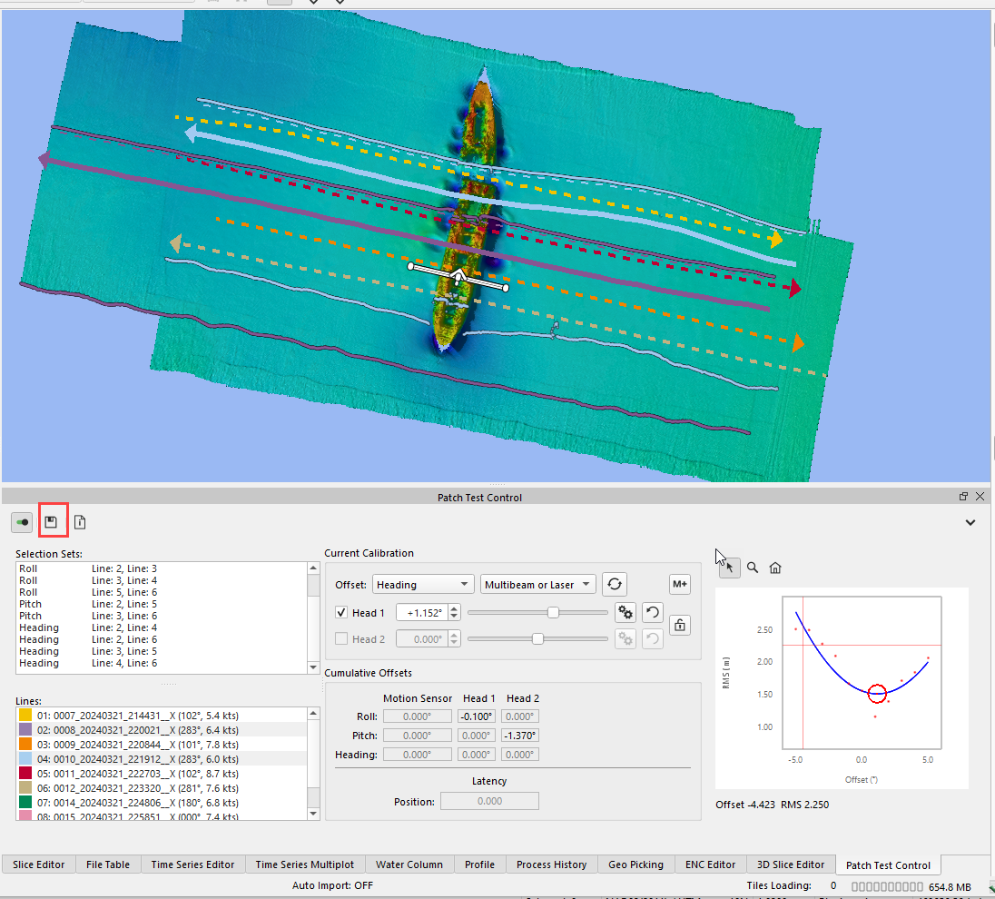

This will pop up another window to save the results. **NOTE: it is advised to uncheck the “Apply Calibration Results” and just save the report.**

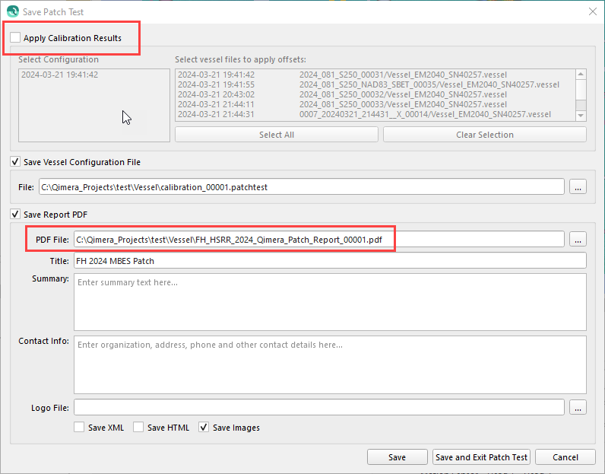

The final (averaged) results can be entered into the Vessel Editor at a later time and the Qimera dynamic surface can be updated to reflect that.

When you close the Qimera Patch Test Tool by clicking the little slider button in the top left corner of the Patch Test Control window:

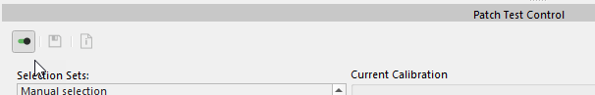

A window will pop up about the Vessel Configuration and whether or not you want to save or apply your results. HIT NO. That way the results will not alter the Vessel Configuration and the next person to perform the patch test will start with a clean slate.

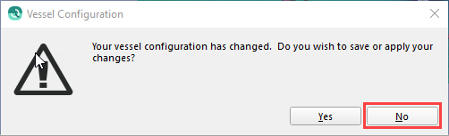

**Record the results in the FH_YYYY_Qimera_Patch_EM2040_Dual_Head_Calc.xls for the year. Each year, there will also be a google drive made for HSRR which has a spreadsheet for offsets. Put these values there too.** Enter numbers for all personnel going through the patch test process.

This calculation table will tell you the offsets to put into SIS5.

**NOTES:**

* After the roll run, the system will ask “You have different TX and RX multibeam locations. Do you want to apply multibeam offsets to both TX and RX?” **CLICK Yes.** This prompt occurs because we have a dual head with two TX and they are at a different node from the RXs. i.e., the TX and RX have different offsets from the RP. Since the TX and RX are mounted to the same plate very close together, it is safe to do this.
* Auto solve will not work if both heads are active. Turn one off as seen in step i. in order to use auto solve. Auto doesn’t seem to work too well with the dual head setup. If that is the case when you run it, just use the slider and entry box to adjust the values to what you think is the correct result.
* Qimera has an RMS graph that populates during patch processing. In general, the “best” value should be at the point with the lowest RMS (bottom of the parabola in the graph). By zeroing to the SAT values, our offsets found during a patch are very small, so this may be difficult to see. If truly zeroed, then a parabola would form in the RMS window. This is how the Auto calculation works (if it works).

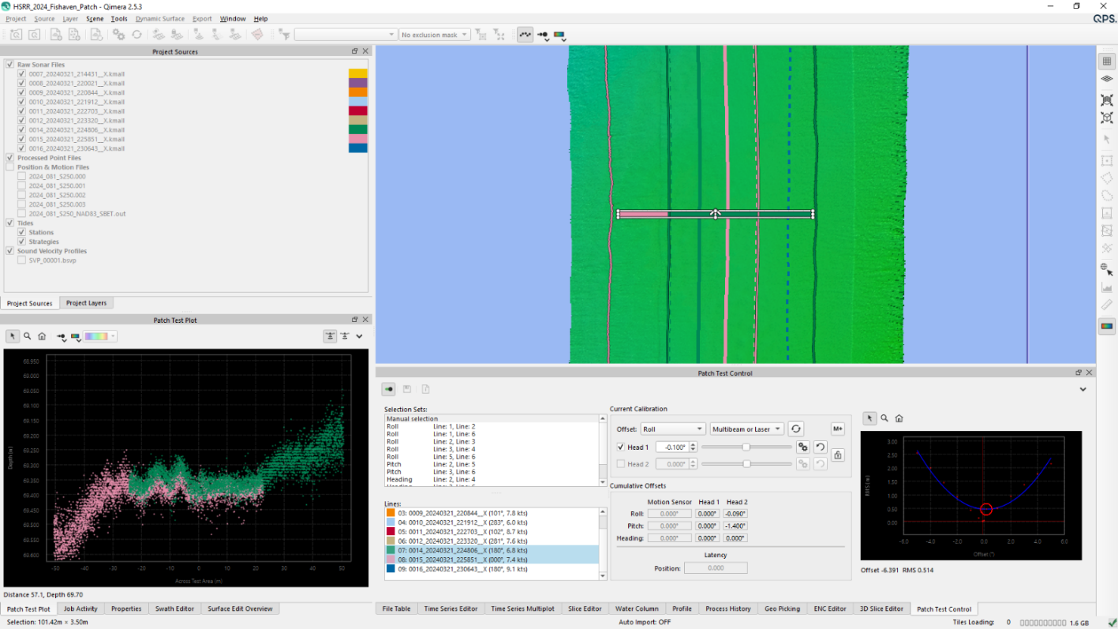

* Because our sonars are far apart, overlap can be difficult to find especially if the lines are not straight. Especially for pitch and yaw, it is very important to align the slice window in the outer beams but within the overlap.

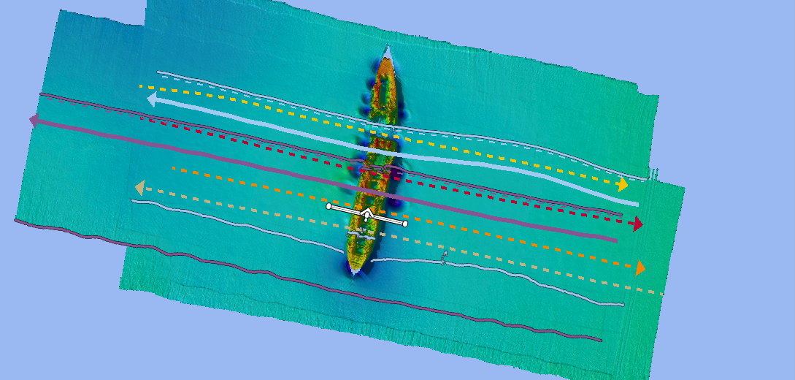

* + - 1. When recording values and updating SIS, remember the QPS reference frame is: 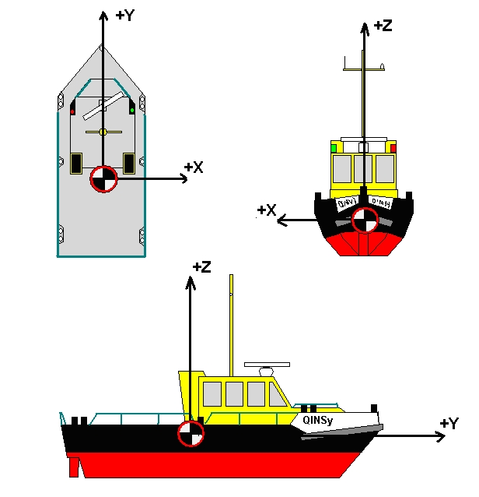
         1. Kongsberg is:

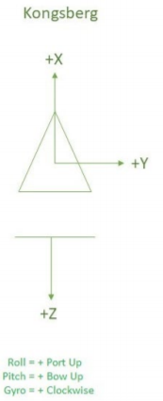

**NOTE: If you come up with a negative offset for Heading (Yaw) e.g., -0.9, that translates into an entry in the SIS5 yaw offset page as 359.9. Negative offset values for Heading are not accepted in SIS5.**

* + - * 1. Caris is:

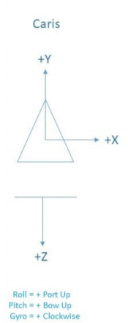

1. Launch/ S-250 Reference Surface: Fish Haven (new location as of 2024)
   1. Reference surface is completed after all sonar and ancillary instrument calibrations are completed. Data and grids are collected and compared against each other for agreement.
   2. Get reference surface from TJ for comparison
   3. Complete reference surfaces near the Fish Haven, flat surface. Not all the lines seen below need to be run. This was just for the first year in the Fish Haven area.

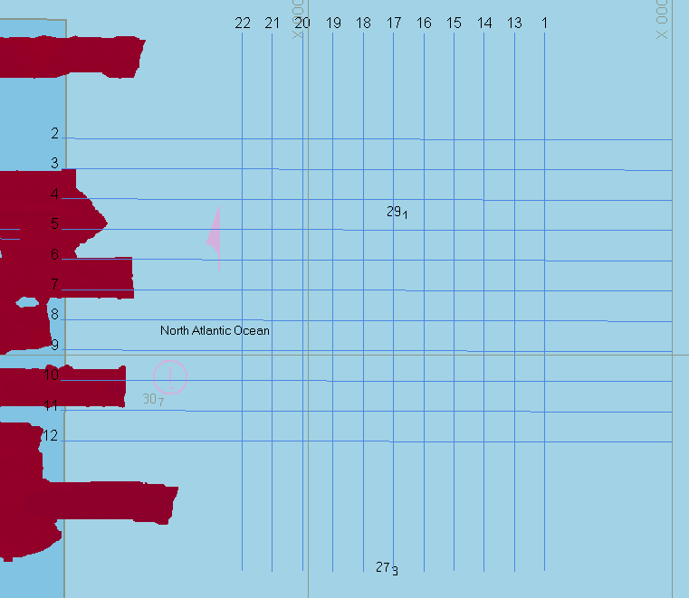

* 1. Process and produce surfaces in Caris or Qimera
  2. Create difference surfaces using Pydro’s “Compare Grids” Tool:

|  |
| --- |
| S250 vs S222 (latest year found) |
| S250 (current year) vs S250 (previous year) |
| 2702 (FH Launch) vs S222 (latest year found) |
| S250 vs 2702 (FH Launch) |

* 1. Follow up on or address any major offset issues visible.